WorkflowMaker – About the samples source code

For WorkflowMaker version 1.0.4 and later
Windows 10 & 11
64-bit only

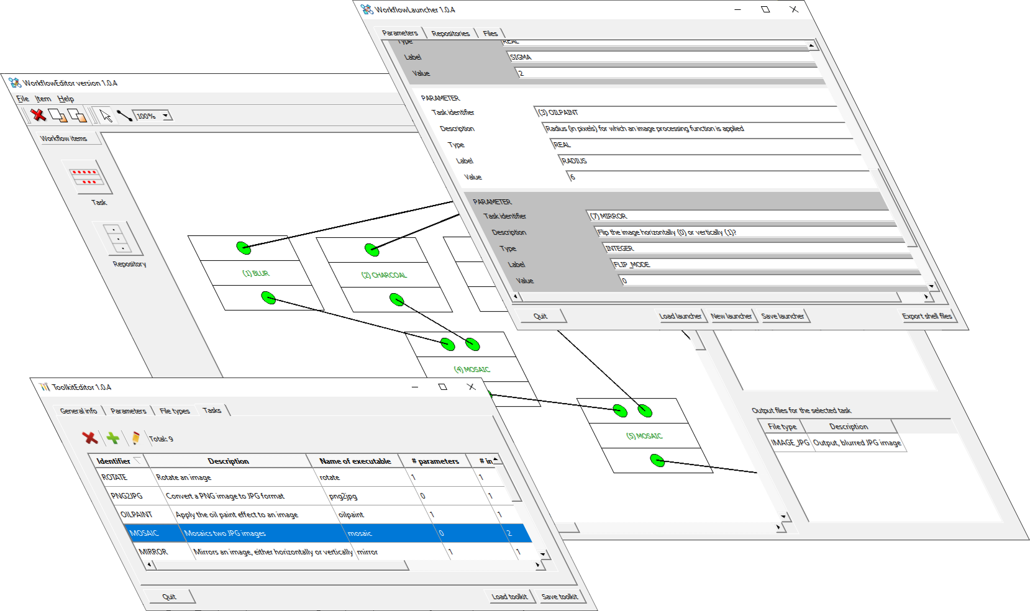



Table of contents
1 About the samples source code 4
List of figures
Figure 1: Folder hierarchy for the source code of the samples. 4

About the samples source code
Figure 1 depicts the organization of the source code once the samples have been installed.

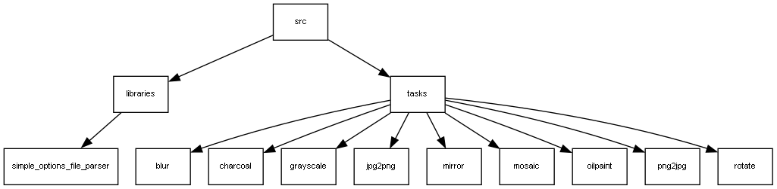Figure 1: Folder hierarchy for the source code of the samples.

The source code is located at the “src” subfolder of the installation directory. If the standard options are accepted when running the installer, then this location is

C:\Program Files\cttc\WorkflowMaker_image_processing_samples

On Windows, it is possible to access the “src” folder by means of the start menu. There, an entry named “WorkflowMaker_image_processing_samples” may be found. Unfolding this entry, another one, named “WorkflowMaker_image_processing_samples Source code folder” may be found. Selecting this entry, the “src” folder will be opened.

As shown in Figure 1, the source code for nine tasks (console applications) and one library has been included.

The library, simple_options_file_parser, is targeted at facilitating the parsing of options files including label + value pairs (as requested by WorkflowMaker). All tasks rely on this library to parse their corresponding options files. This library is self-contained and depends on no other components.

The five tasks are all organized in the same way, consisting always of three files:

xxxxx.cpp.
- xxxxx_options_file_reader.cpp + xxxxx_options_file_reader.hpp.

where “xxxxx” stands for the name of any of the five tasks included. In the case of the mirror task, these filenames are

mirror.cpp + mirror_options_file_reader.cpp + mirror_options_file_reader.hpp

These xxxxx_options_file_reader files implement specific options file readers for each of the tasks, taking care of searching for the appropriate labels and then reading their values. Since each task reads a different set of labels, a specific options file parser is required.

For instance, the labels to parse for the mirror task are INPUT_FILENAME, OUTPUT_FILENAME, and FLIP_MODE. In the case of mosaic, these are LEFT_IMAGE_FILENAME, RIGHT_IMAGE_FILENAME, and MOSAIC_FILENAME.

The xxxxx.cpp files implement the specific logic for each task. A common trait is that all these xxxxx.cpp create an object of the corresponding xxxxx_options_file_reader class to read the parameters controlling its behavior.

To build source, it is necessary to build the simple_options_file_parser first.

Additionally, it is necessary to download and build the ImageMagick library, since all tasks depend also on it. This open-source library has not been included with the samples. It may be obtained here:

https://github.com/ImageMagick/ImageMagick

Then, it is possible to build the tasks.

